Andrew Dykman – Lab 9 – Software Development Lifecycles

Task 1 - Procedure 1-4:) Powerpoint presentation advocating the use of the Prototype design pattern in the Software Design Catalog:

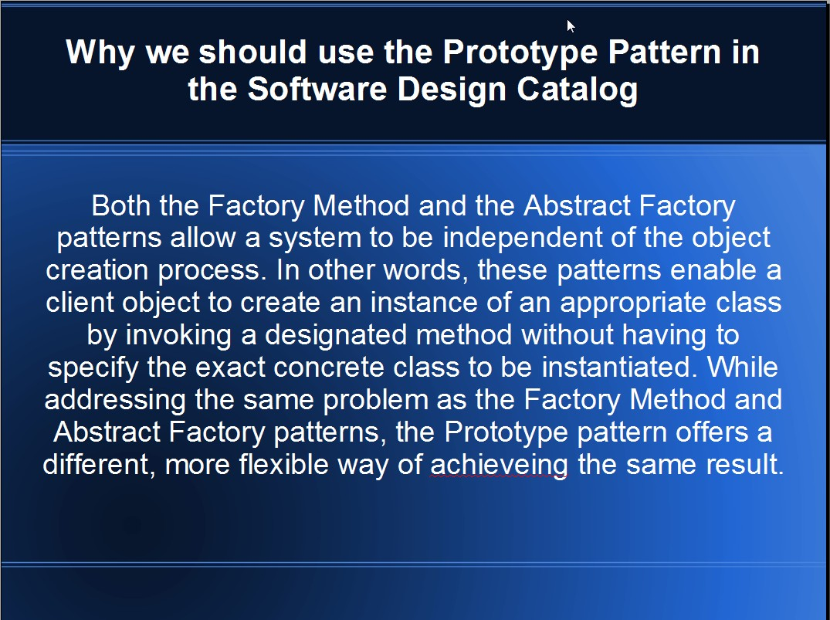
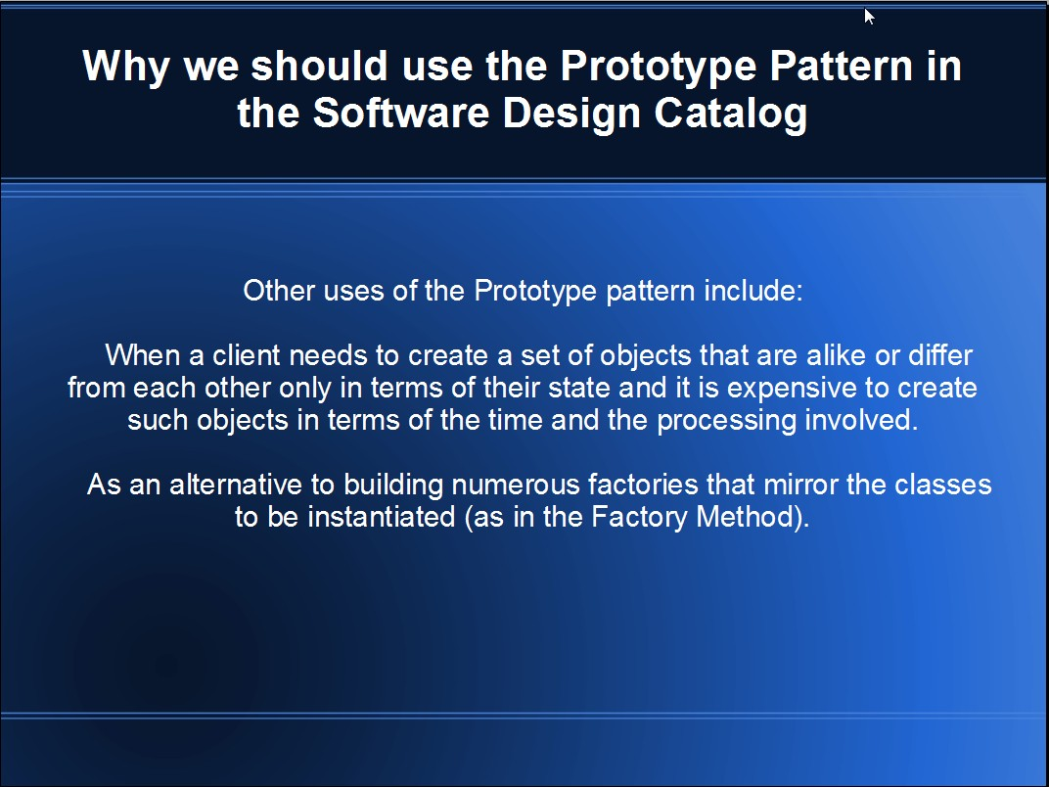

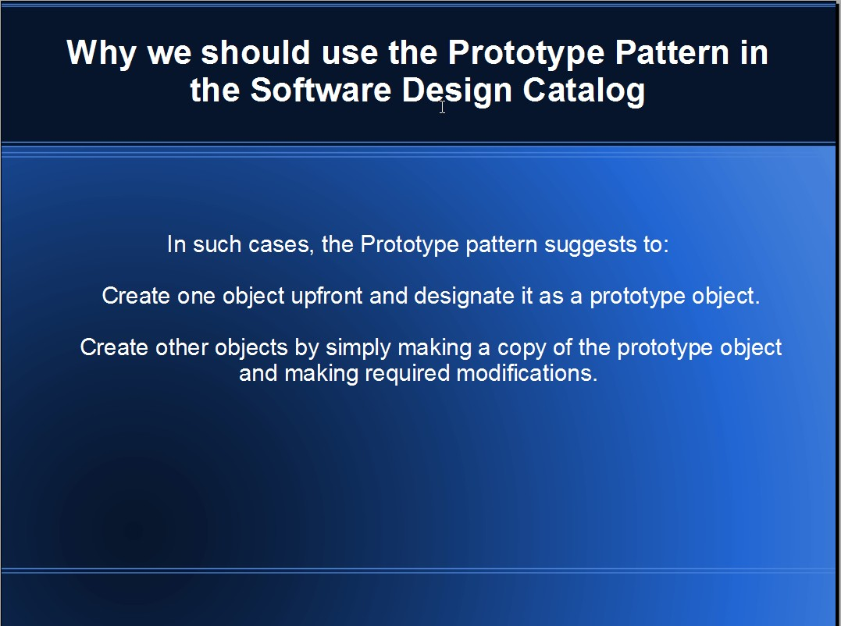
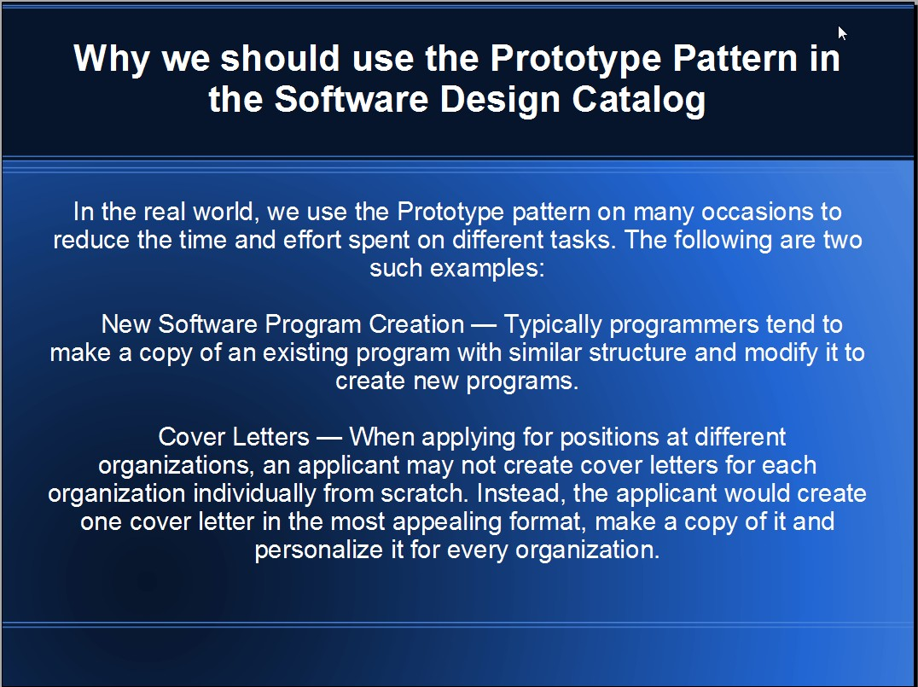

Task 1 - Question 5a:) The factory method pattern is an object orient design pattern to implement the concept of factories. Like other creational patterns, it deals with the problem of creating objects (products) without specifying the exact class of object that will be created. The essence of the Factory method Pattern is to "Define an interface for creating an object, but let the classes that implement the interface decide which class to instantiate. The Factory method lets a class defer instantiation to subclasses.". The builder pattern is an object creation software design pattern.The intention is to abstract steps of construction of objects so that different implementations of these steps can construct different representations of objects. Often, the builder pattern is used to build products in accordance with the composite pattern. The composite pattern in the case of this question, and in many actual cases, is the factory pattern, and in this manner they work together accordingly.

Task 1 - Question 5b:) The difference between a factory class and an abstract factory class: the former uses inheritance to get the concrete implementation, the latter composition.

Task 2 - Procedure 1-3:) Powerpoint presentation advocating the use of the Decorator pattern to meet an extensiblity requirement:

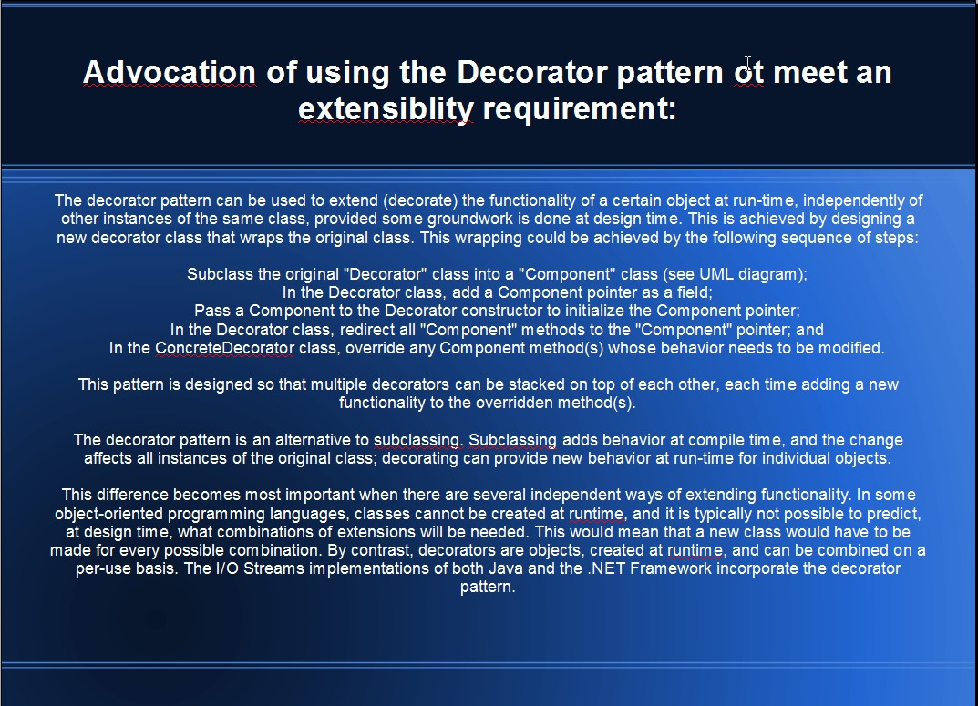
Task 2 - Question C:) Pattern to make a subsystem easier to use: Facade Design Pattern. Why: It provides a unified interface to a set of interfaces in a subsystem. Facade defines a higher-level interface that makes the subsystem easier to use. Most Importantly, it wraps a complicated subsystem with a simpler interface.

Task 2 - Question D:) From a client's point of view, all objects are accessed through interface pointers. A pointer must be in-process. In fact, any call to an interface function always reaches some piece of in-process code first. If the object is in-process, the call reaches it directly, with no intervening system-infrastructure code. If the object is out-of-process, the call first reaches what is called a "proxy" object provided either by COM or by the object (if the implementor wishes). The proxy packages call parameters (including any interface pointers) and generate the appropriate remote procedure call (or other communication mechanism in the case of custom generated proxies) to the other process or the other computer where the object implementation is located. This process of packaging pointers for transmission across process boundaries is called marshaling.

Task 3 – Procedure 1 and Question E:) In Java, the List and Set collections provide iterators, which are objects that allow going over all the elements of a collection in sequence. The java.util.Iterator<E> interface provides for one-way traversal and java.util.ListIterator<E> provides two-way traversal. Iterator<E> is a replacement for the older Enumeration class which was used before collections were added to Java.

Task 3 – Question F:) Iterator adds an optional remove operation, and has shorter method names. Using remove() we can delete the objects but Enumeration interface does not support this feature.

